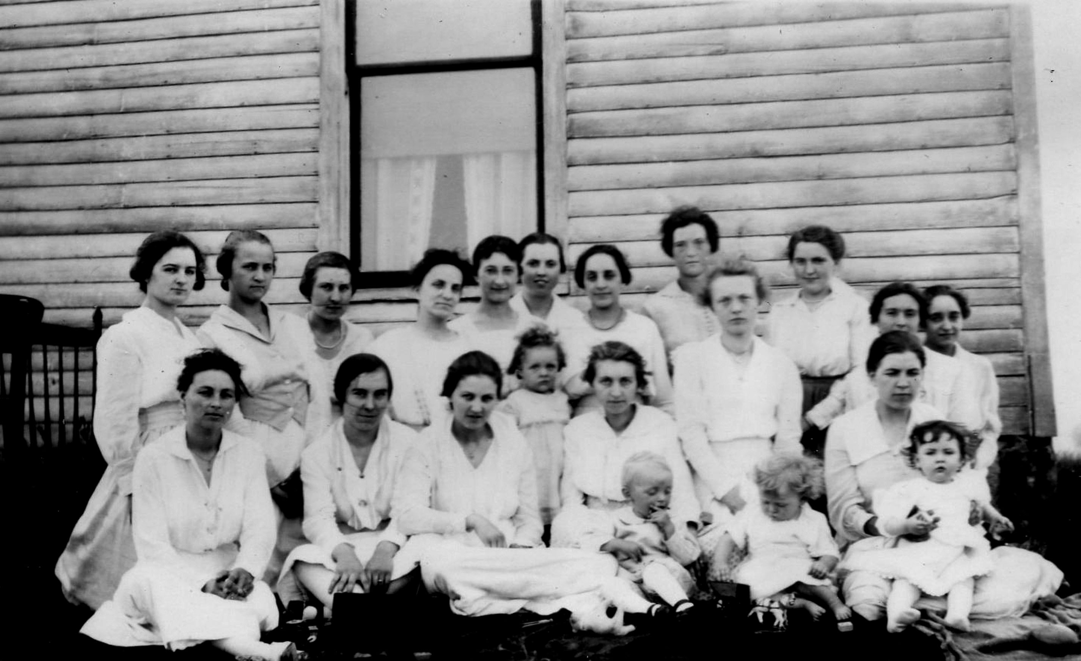
Young Ladies Group - Hudsonville
Back: Etta Gerrits (m. Zwagerman), Clara De Weerd (m. Shriemer), Josie Yonker (m. Mart Boldt), Clara Coburn, Clara Boldt (m. Howard Gillett),
Marguerite Hughes (m. Lee Edson), Myrtle (Chamberlin) De Groot, Blanche Morrill (m. Dorn), Dorie Morrill (m. Burgess), Doris Edson (m. John Nyhuis),
Marie Cook (m. Mc Coy), Alice Chamberlin (m. Vander Boegh)
Front: Nettie Ter Haar, Adah Curtis (m. Fisher), Flora De Cator, Harriet De Groot (daughter of Myrtle), Myrtle De Groot, Baby Nyhuis, Ila (De Cator) Nyhuis, June Burgess,
Baby Densmore, Iva Densmore

